

**VIETNAM NATIONAL UNIVERSITY**

**UNIVERSITY OF SCIENCE**

---------o0o---------

COMPUTER SCIENCE

PROJECT PROGRAMMING TECHNIQUES REPORT

**COURSE REGISTRATION**

**INSTRUCTORS:** **GROUP ID:** 09

1. Dinh Ba Tien
2. Truong Phuoc Loc
3. Do Nguyen Kha
4. Le Thanh Tung

**MEMBERS:**

1. Nguyen Khang Hy 21127618
2. Do The Nghia 21127367
3. Mac Tuan Trung 21127462
4. Nguyen Hoang Tu 21127716

*Ho Chi Minh City, April 2022*

**Contents**

**ACKNOWLEDGEMENT 3**

**ABSTRACT 4**

**I. Data organization 7**

**1. Diagram: 7**

**2. Project ideas: 8**

**II. Subsystems: 9**

***1.* *Teacher (Academic staff)* 9**

***a.* *Information methods:* 10**

***b.* *Managing methods:* 11**

***2.* *Student:* 17**

***a.* *Information methods* 17**

***b. Managing methods* 18**

***3.* *Log out:* 19**

**III. Tasks by each members 21**

**IV. Self-assessment 23**

**VI. Conclusion: 24**

**References 25**

# ACKNOWLEDGEMENT

While we were preparing this project, various information that I found helped us a lot and we are glad that we were able to finish this project and learn many things. Through Programming Techniques Project, this is an immense learning experience, and we also inculcated many personal qualities during this process like responsibility, punctuality, confidence, and other invaluable qualities.

Apart from our efforts, the success of any project depends on the encouragement and guidelines of many others. We take this opportunity to express my gratitude to the people who have been instrumental in the successful completion of this project. We would like to show our deepest appreciation to Mr. Dinh Ba Tien, Mr. Truong Phuoc Loc, Mr. Do Nguyen Kha and Mr. Le Thanh Tung who was abundantly helpful and offered invaluable assistance and guidance. It would not have been possible without the kind support and constant supervision as well as for providing necessary information regarding the project. We are taking this opportunity to acknowledge their support and we hope that they keep supporting us like this in the future. We would like to thank our classmates, who are in 21CLC09, also for their encouragement and help in researching and making our project creative and efficient. We were in debt of all these. Without them, we would not be able to create our project and make it an enjoyable experience.

Programming Techniques Project is a bridge between theoretical and practical learning and with this thinking, we worked on the project and made it successfully. Thanks to our relentless efforts, we are making this project not only for marks but also to improve our knowledge and now we have done an excellent job. Hopefully, we will have another cooperation in the future.

Once again, we would like to express our gratitude to all those who helped us.

*Ho Chi Minh City, April 2, 2022*

Group 9

# ABSTRACT

With the advent of Information Technology, the major focus has shifted from manual systems to computerized systems. The Course Registration System will help the student to gather information about a particular course and they can easily register themselves on a particular course. This system provides several functionalities pertaining to course registration for the students as well as academic staff.

The purpose of the registration process at an academic institution has been mainly to determine which students will be taking courses within the university, and for the administrator (academic staff) to keep its records up-to-dates. Usually, it has been the case that students register for particular courses, or modules, at the same time, and the information collected is used by members of the teaching staff to construct class lists, and offer other academic activities.

The project was both quantitative and qualitative in building several functions. There are 2 types of users in the system. Academic staff members, for example, Ms. Le Thi Anh Thao, Ms. Nguyen Thi Minh Phuc, Ms. Hoang Thanh Tu… Students: in APCS, CLC, VP… He/she has to log in to the system. Then, he/she can view his/her profile information, change password, or log out of the system.

At the beginning of a school year (often in September), an academic staff member will:

1. Create a school year (2020-2021, for example)
2. Create several classes for 1st year students. For example: class 20APCS1, class 20APCS2, class 20CLC1…, class 20CLC11, class 20VP…
3. Add new 1st year students to 1st-year classes.
4. For quick input, he/she can import a CSV file containing all students in a specific class to the system, instead of adding one by one: No, Student ID, First name, Last name, Gender, Date of Birth, Social ID.
5. He/she does not need to add 2nd year, 3rd year, or 4th-year students, because these students had been added in the previous years.

There are 3 semesters in a school year: Semester 1 (Fall), Semester 2 (Summer), and Semester 3 (Autumn).

At the beginning of a semester, an academic staff member will:

1. Create a semester: 1, 2, or 3, school year, start date, end date. Choose the school year that the newly created semester belongs to. The created semester will be the current / the default semester for all the below actions.
2. Create a course registration session: start date, end date.
3. Add a course to this semester: course id, course name, teacher name, number of credits, the maximum number of students in the course (default 50), day of the week, and the session that the course will be performed (MON / TUE / WED / THU / FRI / SAT, S1 (07:30), S2 (09:30), S3(13:30) and S4 (15:30)). A course will be taught in 2 sessions in a week.
4. View the list of courses.
5. Update course information.
6. Delete a course.

When a course registration session is active, a student can:

1. Log in to the system, of course.
2. Enroll in a course. If 2 sessions of the new course are conflicted with existing enrolled course sessions, he/she cannot enroll in it. He/she can enroll in at most 5 courses in a semester.
3. View a list of enrolled courses.
4. Remove a course from the enrolled list.

When a course registration session is close, a student still can:

1. View a list of his/her courses. He/she will study these courses in this semester.

At any time, an academic staff member can:

1. View a list of classes.
2. View a list of students in a class (for example, 20APCS1…)
3. View a list of courses.
4. View a list of students in a course

At the end of a semester, an academic staff member can:

1. Export a list of students in a course to a CSV file
2. Import the scoreboard of a course. A scoreboard will have at least the following columns: No, Student ID, Student Full Name, Total Mark, Final Mark, Midterm Mark, Other Mark. (An academic staff member will export the list of students in a course, send the CSV file to the teacher, the teacher will enter student results in this file, send it back to the staff, and then the staff will import the scoreboard to the system)
3. View the scoreboard of a course.
4. Update a student result.
5. View the scoreboard of a class, including final marks of all courses in the semester, GPA in this semester, and the overall GPA.

When the scoreboard has been published (by the academic staff member), a student can:

1. View his/her scoreboard.

# Data organization

## **Diagram:**

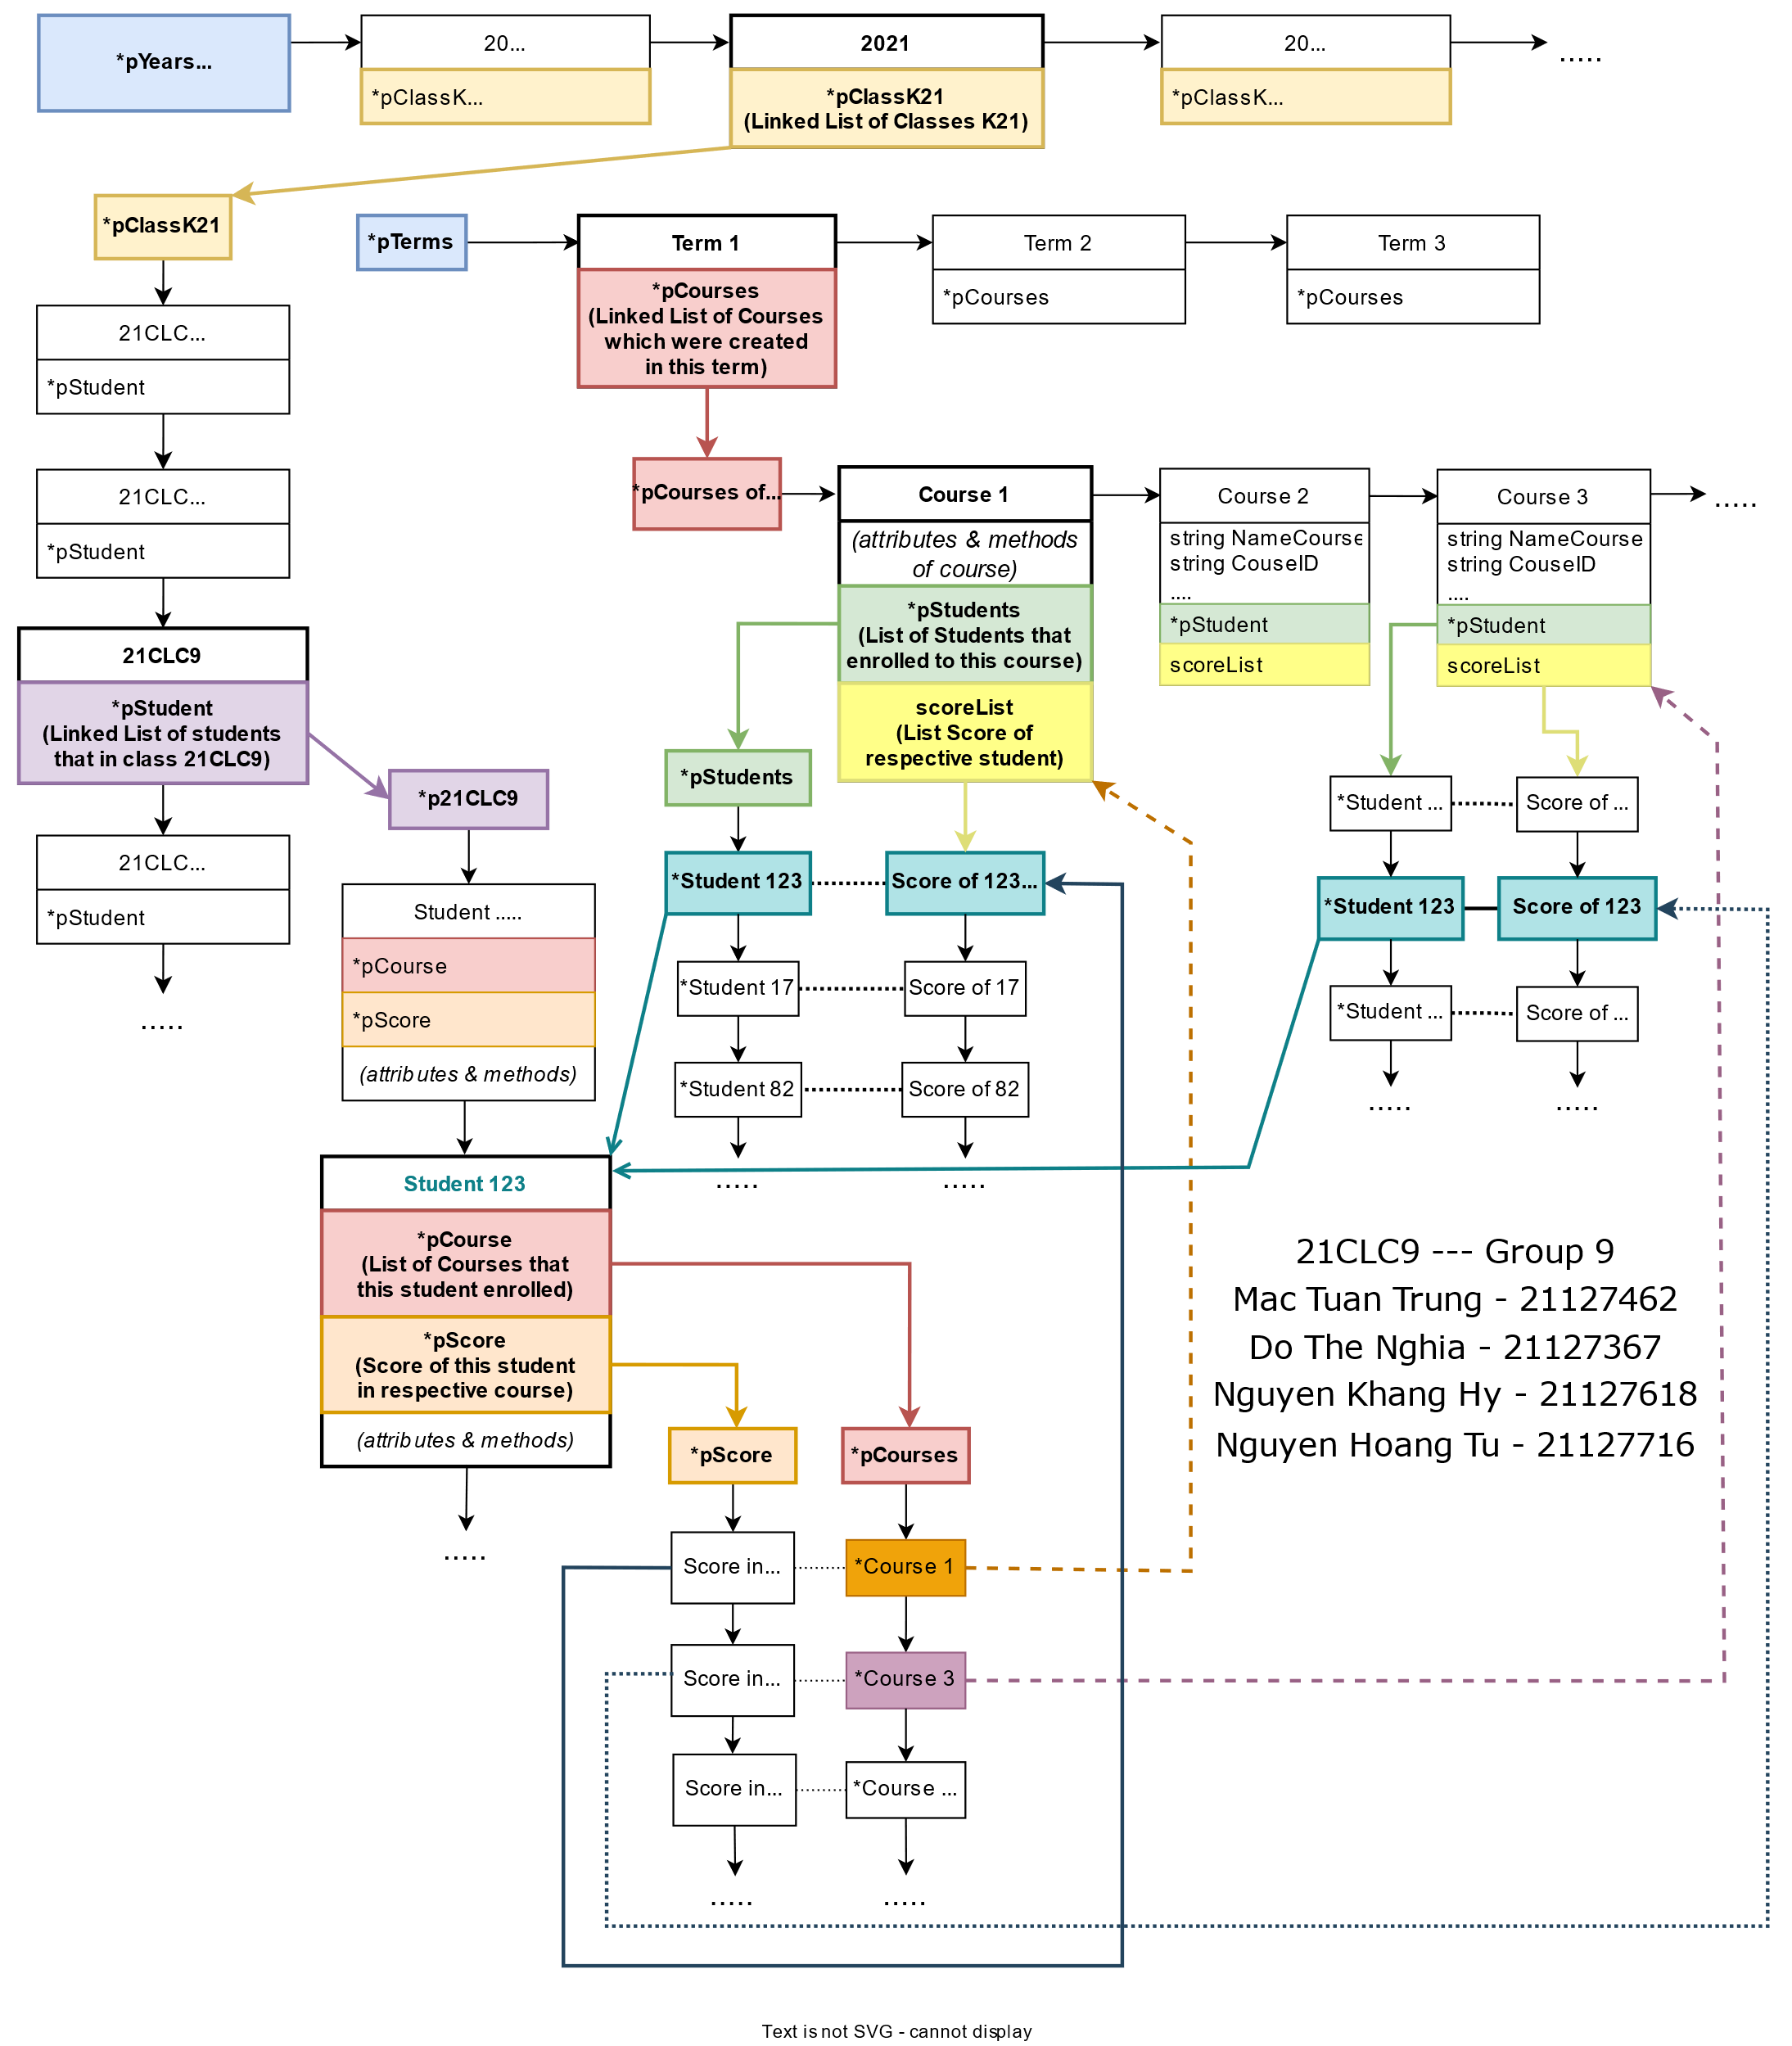

Figure 1 Data structure

## **Project ideas:**

|  |  |
| --- | --- |
|  | **Teacher** |
| At the beginning of the year | Create a school year |
| Create classes for first–year students |
| Add the first – year students into classes (By hand or file) (No, student ID, first name, last name, gender, date of birth, social ID) |
| The 2nd, 3rd, 4th… go up a grade |
| At the beginning of the semester | Create a semester (Year, begin date, end date) |
| Create a course registration |
| Add courses (ID, name, teacher, number of credits, the maximum number of students (50), weekdays and study – time |
| View the course list |
| Update the course information |
| Delete courses |
| At the end of the semester | Export the course’s student list |
| Enter the student’s marks (No, student ID, student full name, total mark, final mark, midterm mark, other mark) (By hand or file) |
| View the course’s score board |
| Fix the student’s marks |
| View the class’s score board |
| At any time | View the class list |
| View the class’s student list |
| View the course list |
| View the course’s student list |
|  |  |
|  | **Student** |
| At the course registration time | Login |
| Register courses |
| Cannot register for two identical courses |
| Maximum course can be registered at one time: 5 |
| When the course registration time has ended | View the course list |
| When the score board is published | View his/her score board |
|  |  |

# Subsystems:

## *Teacher (Academic staff)*

* At first, in order to work with the system, we have to sign in to it.

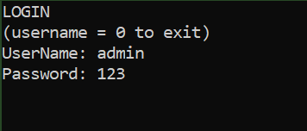

Figure 2 Teachers log in to the system

* As default, an account has been created before with username is *‘admin’* and password is *‘123’*. Of course, if teacher does not want to continue the system for any reasons, he/she press *‘0’* into Username to exit from the system. Now, we are in the menu of teacher (academic staff).

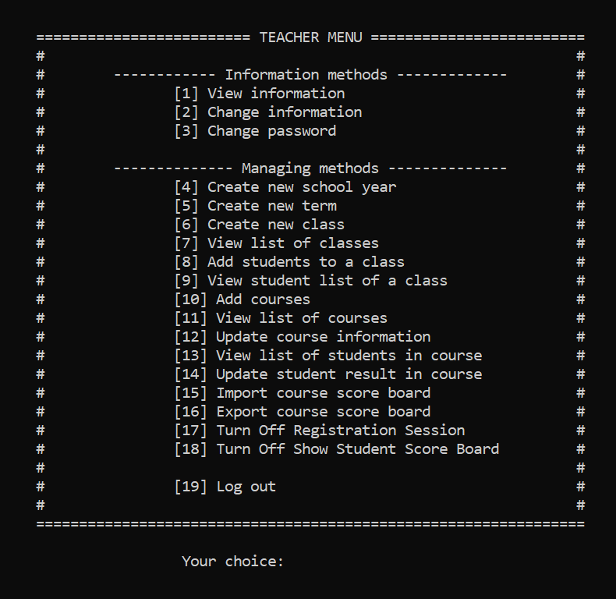

Figure 3 Teachers' menu

* In Teachers’ menu, the system has a bunch of methods, but it just has only two types of methods. They are *Information methods* and *Managing methods*.

### *Information methods:*

* Choice *No.1 – View information*. Teachers can view information of themselves by choose choice No.1 in the menu. Some personal information would be represented like: first name, last name, gender, date of birth, social ID and mail.

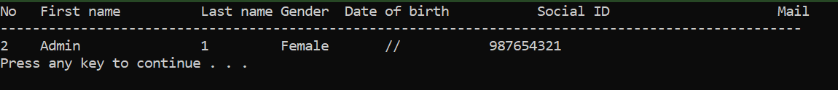

Figure 4 Overview of teacher (Teacher's information)

* If some information of teacher is wrong, we can edit manually by choosing choice *No.2 – Change information*. We can change name (first name, last name), date of birth (dd/mm/yyyy), gender (*‘x’* or *‘X’* if female, and *‘\n’* if male).

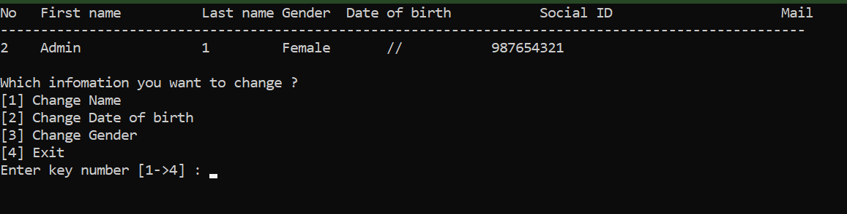

Figure 5 Teachers' Changing Information

* For preventing information leakage and protect sensitive information, the system also supports the function to edit password of user by choosing choice *No.3 – Change password.* Because password is the key to access to the system, so teacher have to verify the account for further changing in password.

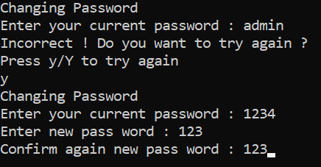

Figure 6 Teachers' verifying to change password

### *Managing methods:*

* At the beginning of the academic year, the teacher can create a new year by choosing choice *No.4 – Create new school year*. It will automatically create the next year depends on the previous year. For example, if the previous year is K21, it automatically creates the next year with K22.

* Text

  Description automatically generatedAdditionally, we also create new term in the academic year by choosing choice *No.5 – Create new term* (we have three terms in a year, it also automatically creates the next term depending on the current term).
* *Text

  Description automatically generated*Classes of the students are created manually by choosing choice *No.6 – Create new class.*  When choosing No.6, teacher needs to choose exactly which year he/she want to add more classes (often freshmen).
* After creating a lot of classes for all student, we can view the classes of each year, by choosing choice *No.7 – View list of classes.*

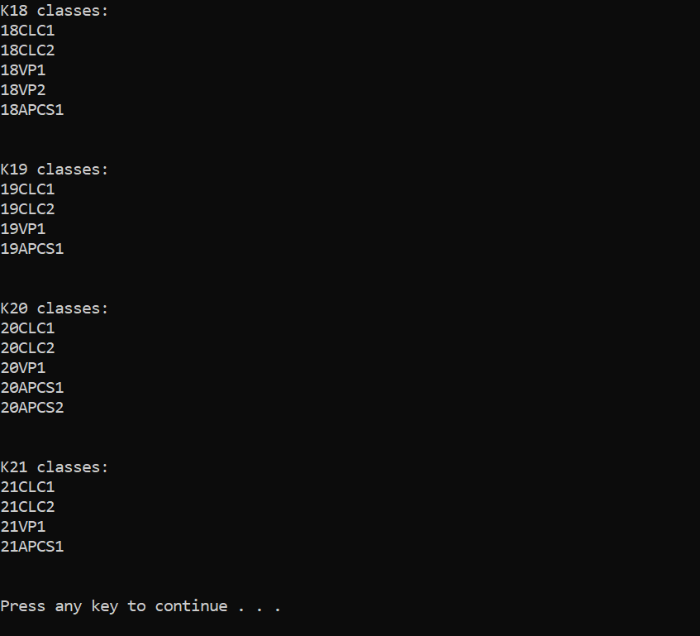

Figure 7 Teachers view the classes

* When all classes are available, it time for teacher to add all student to the class by choosing choice *No.8 – Add students to a class*. We have two choices, adding by csv file for adding manually.

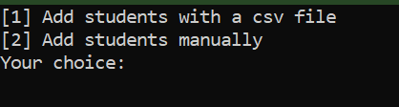

Figure 8 Two ways to add students to a class

* After adding students to class, teacher can view all the students of each class by choosing *choice No.9 – View student list of a class.* Firstly, teacher will enter which year, he/she want to view, after that, choosing exactly the class he/she want to view.

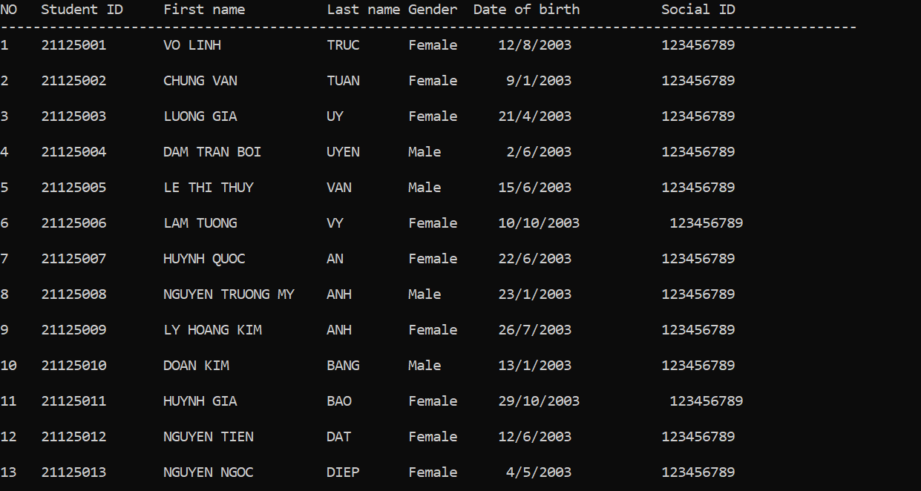

Figure 9 View student list

* Next, the teachers can add courses into the system manually by choosing *No.10 – Add courses*. We have to enter some basic information of a course like course ID, course name, schedule 1&2, max member of course, the year will be taught.

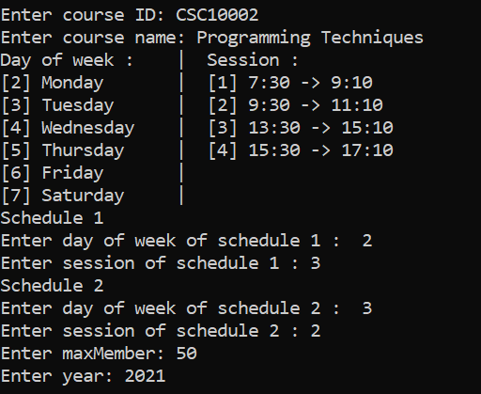

Figure 10 Add courses manually

* Of course, teacher can view all the courses him/her created before by choosing choice *No.11 – View list of courses.*

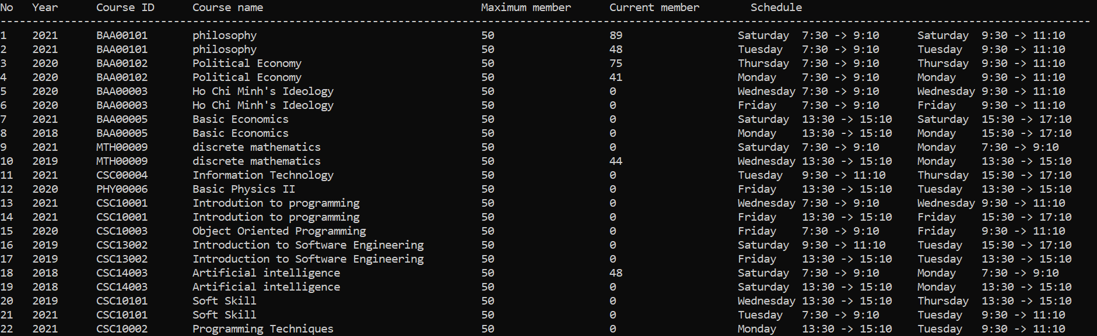

Figure 11 View list of courses

* Sometimes, the information of course may be wrong, so the system also supports teacher to edit the information of courses by choosing choice *No.12 – Update course information.* Firstly, teacher have to choose exactly term which has the course him/her want to update. Next, all the courses of the term will be represented in the screen and he/she will choose the serial number of the course him/ her want to change. Finally, choose which information you want to edit.

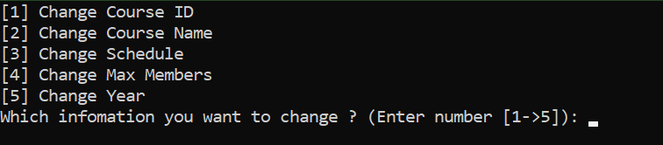

Figure 12 Update course information

* After all courses are available, it is time for students to register courses. Teacher will turn on the Course registration mode by choosing *No.17 – Turn On Registration Session,* if time is over, teacher also choose No.17, but now it is *Turn Off Registration Session*.
* When all the time of Registration Session is over, teacher can view the students registering each course by choosing *No.13 – View list of students in course.* Like update course, firstly teacher also have to choose exactly term which has the course he/she want to view. Then all the courses are represented in the screen, and he/she will choose the serial number of the course he/she want to view. The student list of a course has serial number, student ID, first name, last name, midterm mark, final mark, other mark and total mark. However, student cannot view their score if teacher does not turn on *No.18 – Turn On Show Student Score Board* (usually we just can view our score board at the end of the term).

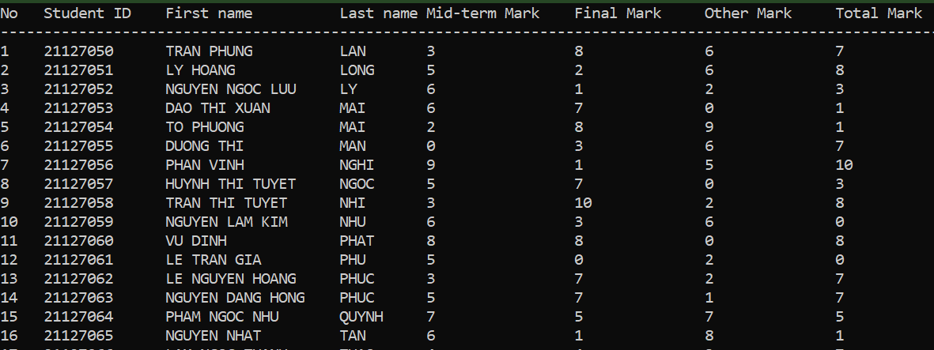

Figure 13 View list of student in course

* If student want to remark, and teacher lost some marks of them, he/she have to update the score board by choosing choice *No.14 - Update student result in course*. After choosing the student of the class of the term, teacher have to edit manually student’s score.

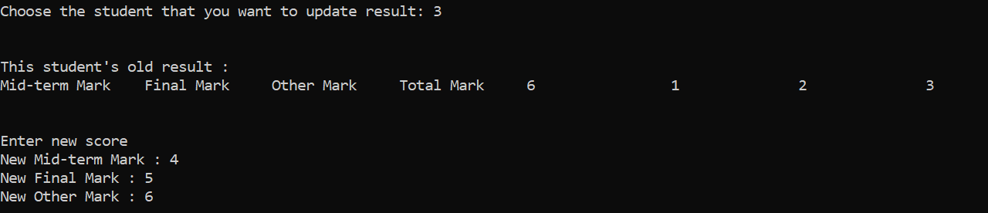

Figure 14 Update student result in course

* By the end of the term, teacher have to export and import the score board for many reasons, the choice *No.15 - Import course score board* and *No.16 - Export course score board* will help them with that. With importing, after choosing the course, teacher have to enter the path of csv file, after that all the score of students will be updated. With exporting, we just have to choose which course you want to export, and automatically, the csv file of it will be store at folder Data/Export.

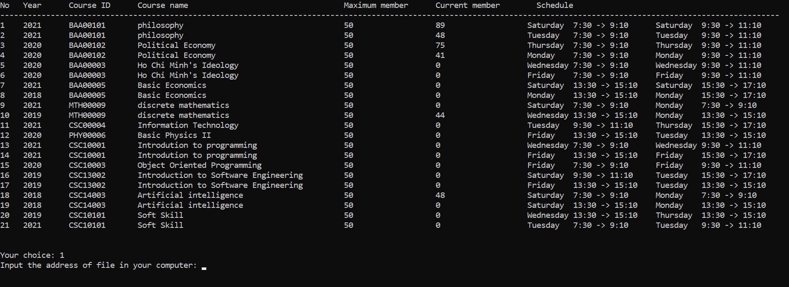

Figure 15 Import course score board by input the path of csv file

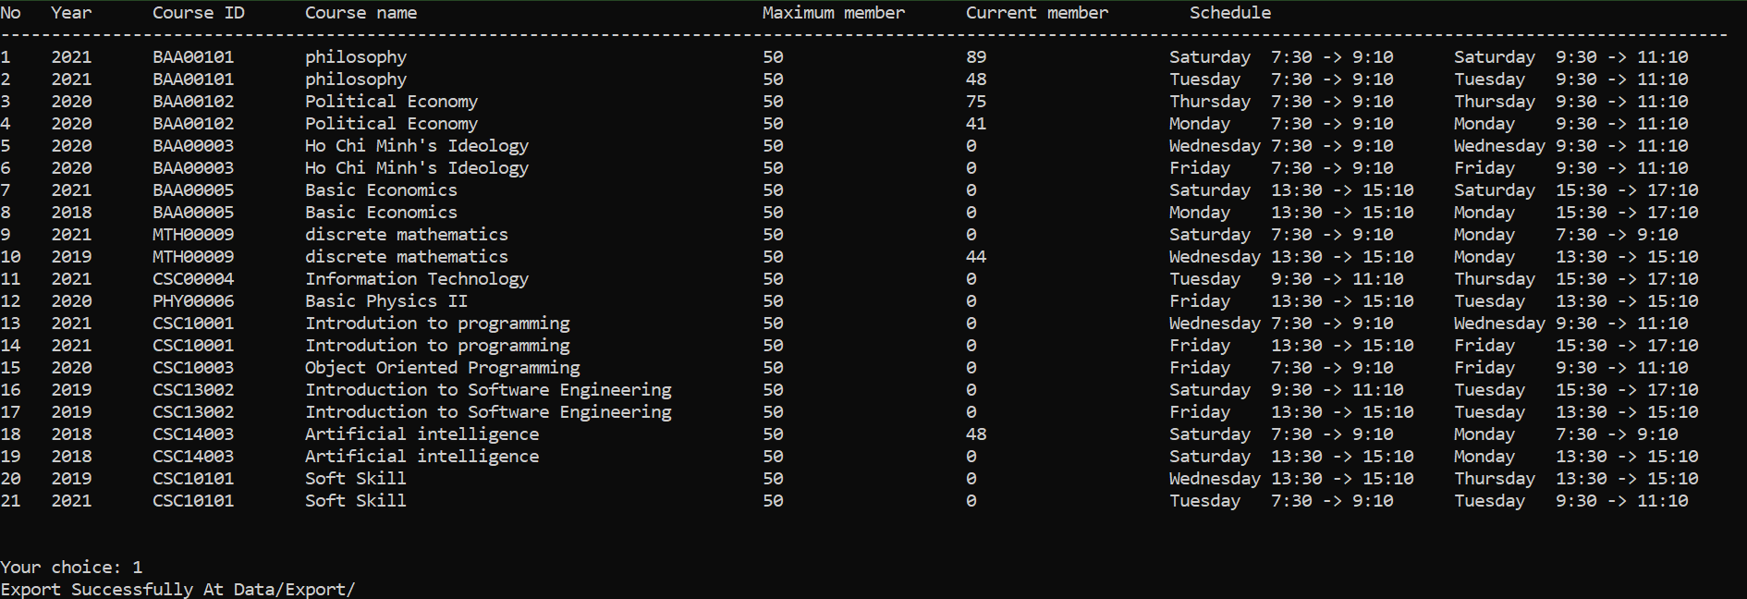

Figure 16 Export course score board and save it at Data/ Export

## *Student:*

* Like teacher, to work with the system, student also have to sign in. As default, username of student is student ID, password is date of birth (for instance, 1/1/2003, password is 112003).

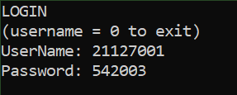

* Of course, if student does not want to continue the system for any reasons, he/she press *‘0’* into Username to exit from the system. Now, we are in the menu of student.
* Student’s menu has two methods *Information methods* and *Managing methods* as well.

### *Information methods*

* Choice *No.1 – View information*. Students can view information of themselves by choose choice No.1 in the menu. Some personal information would be represented like: first name, last name, gender, date of birth, social ID.

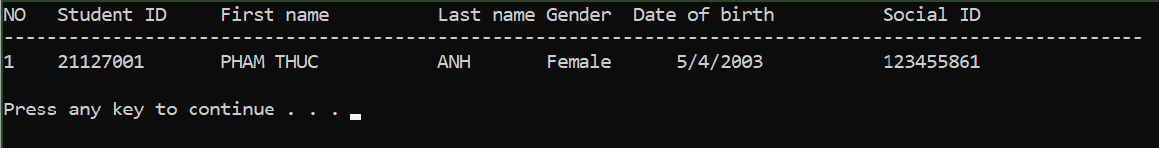

* For preventing information leakage and protect sensitive information, the system also supports the function to edit password of user by choosing choice *No.2 – Change password.* Because password is the key to access to the system, so student have to verify the account for further changing in password.

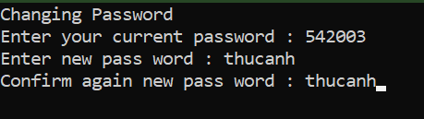

### *b. Managing methods*

* To enroll courses to learn, student have to choose choice No.3 – Enroll in Courses. If it is not time to enroll (it means teacher turn off the Registration Session Mode), we cannot enroll anymore.

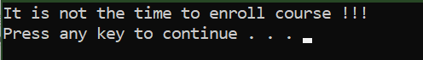

* If it is time for student to enroll courses, it will have some different.

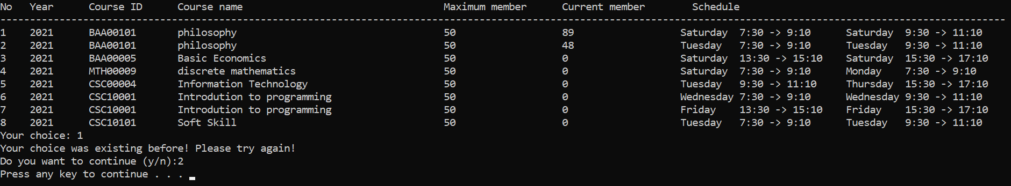

* All courses are displayed in screen and student enter the serial number of courses to enroll it. If the course was existing before, or conflicted with other courses (about schedule), the system would alert student to choose another one for better time management. After enrolling, student can view all the enrolled courses by choosing *No.4 - View list of enrolled courses*.

**

* Student also can view their score board by choosing choice *No. 5 - View score board*. However, student just can view it when teacher turn on the View Score Mode (usually at the end of term, teacher will turn it on).
* Sometimes, student can enroll inaccurately the courses, so the system supports them to remove it from the list of enrolled courses by choosing choice *No.6 - Remove course from the enrolled list.* Of course, after removing the course out of the enrolled list, your name is also removing from the student list of this course. In order to removing enrolled course, you just have to choose the serial number of the course and then it will be removed successfully.

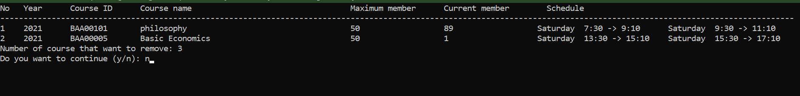

## *Log out:*

* To make sure that all the changings will be saved, user (teacher and student) have to log out properly. With teacher, choosing choice No.19, with student, choosing choice No.7 to log out.
* Graphical user interface, text, application

  Description automatically generatedThen, at the username, enter *‘0’* to exit out of the system. Now, all the changings are saved.
* All data will be saved in this folder after exit the system.

**FOR MORE INFORMATION, PLEASE WATCH OUR VIDEO AT THE LINK:**

<https://www.youtube.com/watch?v=gPm6RMtQ4NA>

# Tasks by each member

|  |  |  |
| --- | --- | --- |
| ID | Name | List of tasks |
| 21127462 | Mac Tuan Trung | * Build class singly linked list * Build class year, term * Complete menu of academic staff and student * Add functions and combine code together in 2 menus for user to choose actions * Add new year and new term * Add new class and course * Login system for student * Login system for academic staff * Read CSV file to add students to a class * Update student result by CSV file * View list of classes * View all students of a class * Turn on/off registration session and allow students to view their scoreboard * Show student score board * Design data organization for saving after existing program * Import all data reload everything into the program when start running the program * Export data to save after exiting program |
| 21127367 | Do The Nghia | * Build class User and class Student, Teacher inherits from class User * Change password method * View, Change information of user * Get information by importing CSV file * Resolve conflicts in Update course information about Schedule * Update menu interface * Build class Score * Show students’ score in a course * Update student result method * Update Course information * Show student list in a course * Show score board of Student in enrolled courses * Calculate overall GPA * Fix bug in User, Score and Course * Edit video and upload to Youtube * Draw Diagram of Data organization |
| 21127716 | Nguyen Hoang Tu | * Build class Class * Build the function to extract data of a student, check student ID to build the function to add students into classes * Create classes * Add students into classes * View the list of classes * Build the extract data from class ID or name so as to category them in to different years. Example: K21, K20… * Remove students from a class * View the class information: ID, size, student list * View a student’s information inside a class * Build a basic menu * Help to write report: Project ideas, checking spellings and grammar… |
| 21127618 | Nguyen Khang Hy | * Create a course registration session * Add a course to this semester * View the list of courses. * Update course information. * Delete a course. * Enroll in a course. * View a list of enrolled courses. * View list of students in a course. * View list of courses. * Remove a course from the enrolled list. * Write report. * Format the table/ output (table in User information, course information). * Fix bugs. * Split file header, cpp,.. |

# 

# Self-assessment

|  |  |  |  |  |
| --- | --- | --- | --- | --- |
| ID | Name | Self-assessment | | Self-grading |
| **Pros** | **Cons** |
| 21127462 | Mac Tuan Trung | * Completed all tasks * Supported others to complete their task * Contributed many valuable ideas | * Work that assigned to everyone is not really reasonable | 9 |
| 21127367 | Do The Nghia | * Always complete all missions early * Support others when they are in trouble * Have many creative ideas * Diligent, hard working | - Sometimes is not serious at work | 9 |
| 21127716 | Nguyen Hoang Tu | * Complete all tasks assigned by the team leader with percentage of completion is about 90% | * Late for meeting once | 8 |
| 21127618 | Nguyen Khang Hy | * Perform all tasks leader given with percentage of completion is 95% * Discuss and give opinion in every meeting minute of group. * Hard-working | * Be absent from meeting minutes twice. | 8 |

# Conclusion:

*Based on the assessment of leader about percentage of achieving the project*

|  |  |  |
| --- | --- | --- |
| *ID* | *Name* | *Percentage* |
| 21127462 | Mac Tuan Trung | 27.5% |
| 21127367 | Do The Nghia | 27.5% |
| 21127716 | Nguyen Hoang Tu | 20% |
| 21127618 | Nguyen Khang Hy | 25% |

# References

[1] [Stack Overflow - Where Developers Learn, Share, & Build Careers.](https://stackoverflow.com/?fbclid=IwAR2ZlJqIutG5FKroyu-gr4rCHKNiW2QNsf2qV0hntEp4LQqvFTvTn2L5WUU)

[2] [GeeksforGeeks | A computer science portal for geeks.](https://www.geeksforgeeks.org/?fbclid=IwAR3pY_xHVnmQ3scliHmyamKQS4nqRnZd8TLuDpMTJdv9SiiqXCf0QuIabYQ)

[3] [cplusplus.com - The C++ Resources Network.](https://www.cplusplus.com/?fbclid=IwAR1TZrQq7Gevrt9C9MhZIr89mYizo0EZvpyf53WFCsRMh8RKTfyyQMc-fMQ)